ERfinder posts on Free Solid State/mechanical energy
compiled by wattups on May 2nd, 2007

Thread Location :
overunity.com The international free energy research forum > Forum > Electronic solid states setups > MEG circuits and OU-transformers > Free Solid State/mechanical energy

Thread Page 6

Re: Free Solid State/mechanical energy
« Reply #58 on: February 10, 2007, 02:50:36 PM »

Hello All,

This is my first post...

Tesla pros please refrain from correcting me until you have constructed the circuit yourself.....

Please enjoy.....

Wire sizes, and their relationships can be understood by dissecting an auto ignition coil (albeit this is limited, because the designers of these apparatus don't take heed to what Tesla said about weight). I do realize that in this example the secondary winding is small, but here scaling is an option. The sky's the limit.

For fun use a primary winding length of 144 inches, secondary length is irrelevant so long as the weight of the secondaries (individually) equal the weight of the primary. I have not constrained myself to any specifics when it comes to wire sizes and neither should anyone else.

Start with a 24 pole switch. Once you build and work with the circuit you will begin to understand that there is a relationship between the number of poles and primary winding length! Stick with the wire length of 144, and harmonics of this number!

The circuit was drawn the way it was so that it could be seen how one part of the system is related and interdependent on another. What should be observed is how the fields are built up and how they
collapse, and where they go when they do! !!!Collapse!!! This circuit is of a motor, the rotary switch should be mounted on the same shaft as the magnet ring. The magnet ring is a mystery in itself, as their is no magnetic field being radiated from it .

Hold questions until after you have done what has been suggested. I say it like this because once you have built it, all your questions will anwser themselves.

The quest for overunity is a DEAD END. True Unity is the goal, systems where you take nothing you just use the flow! Riding the on the waves (fields) of nature!!!

Study the patents, study the diagram, and above all have fun, you have nothing to lose and everything to gain!!!

Regards

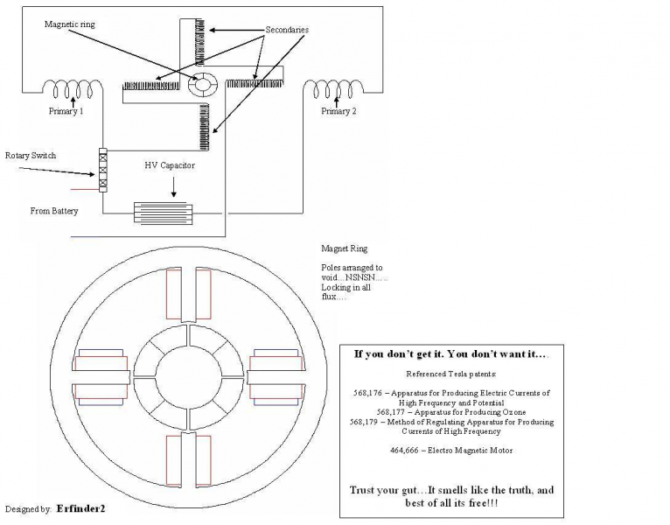

Thread Page 7

Re: Free Solid State/mechanical energy
« Reply #60 on: February 10, 2007, 09:41:57 PM »

Hello,

No I do not have pictures, and will not make any. If you need proof, build it for yourself. It works!!! I am working on a description which I will be posting when it is finished. It will be very short. In the mean time study the patents mentioned and review the diagram. In all honesty you don't need me to explain anything as more than enough info has already been provided. Unfortunately for me many are asking questions and it seems that I must explain a few things, this I will do after which I will sit back and see who really wants this stuff. Just look at the drawing, trace with your finger how the current flows through the circuit. It should be seen immediately that current is not allowed to travel through the whole circuit. This is where things get exciting. Just look at the drawing!!!
Regards

Thread Page 7

Re: Free Solid State/mechanical energy
« Reply #62 on: February 13, 2007, 06:19:25 PM »

barbosi, pese, and anyone else interested

Hello,

The 144 inches is based on a 22.5mm inch. Huh Yeah!!! I know how it sounds. I in my researching I have learned of a measuring system used by the ancients. This system was brought to my attention by Wayne Thompson. Information on this system can be obtained by reviewing his website.

Weights and linear dimensions are interchangeable, this being said anything goes.

www.themeasuringsystemofthegods.com/index.html

Quote taken from the site:

"The Three Metrics that are most common to Free Energy Devices are
1080/45 = 24 mm inch and the 1080/48=22.5 mm inch and the 1080/42 Metric.
The 25.4 mm Inch has NO scientific value as you are led to believe, it is only to deceive you."

I have not been able to locate where Tesla made the statement about the weights of his primaries and secondary coils, but the following quotes are very important to understanding my diagram and the patents which I suggested.

512,340 - Coils for Electro Magnets

“I have found that in every coil there exists a certain relation between its self-induction and capacity that permits a current of a given frequency and potential to pass through it with no other opposition than that of ohmic resistance, or in other words, as if it possessed no self-induction. This is due to the mutual relations existing between the special character of the current and the self-induction and the capacity of the coil, the latter quality being capable of neutralizing the self-induction for that frequency. It is well known that the higher the frequency or potential difference of the current the smaller the capacity required to counteract the self-induction; hence in any coil, however small the capacity, it may be sufficient for the purpose stated if the proper conditions in other respects be secured.”

593,138 - Electrical Transformer

“If the rate at which a current traverses the circuit, including the coil, be one hundred and eighty-five thousand miles per second, then a frequency of nine hundred and twenty-five per second would maintain nine hundred and twenty-five stationary waves in a circuit one hundred and eighty-five thousand miles long, and each wave would be two hundred miles in length. For such a frequency I should use a secondary fifty miles in length, so that at one terminal the potential would be zero and at the other maximum."

As I am constantly adding to and modifying my understanding it may take some time before my paper is finished; I hope that most who are viewing this can accept that. I will not be rushed, nor pressured into exceeding my means. Because it will take me some time I have no problem with answering a few questions I am no scientist, so my answers will not be in line with the mainstream view. It should be understood that I am not trying to give the answers away, as this would not benefit anyone, including myself, I will however help where ever I can those individuals willing to modify their view, find the answers themselves, as they are here and have been here since the very beginning. It is my opinion that a majority of what we consider fact is in fact nothing more than theory. Until electricity, magnetism, gravity, and electrostatics and their relationships to one another are perfectly understood (by observing them in nature) no new technology can nor will come forward.

Review the diagram, study the patents, and take note of the above quotes. All of these things combined are more than enough for anyone of any level to build a working device.
Regards
P.S. I will not make photos, ever, so hate me or hate me. I am sorry, but nothing anyone says will change this. If this is not acceptable then I will leave, this is not a problem, I am here to inspire, not to change the world. The proof you require is within your grasp. Study, and build!

Thread Page 7

Re: Free Solid State/mechanical energy
« Reply #67 on: February 15, 2007, 02:31:48 PM »

Charlie_V,
Hi, sorry to have to burst your bubble, but I don't think you know what I am doing! I am not trying to do anything. It's done! You are trying! (Please don't take offence to this) You cannot explain what is going on in my circuit with mainstream science as your basis. If you could people all over the world would be replicating Tesla! Free energy as we mistakenly call it would be the norm. (Nikola Tesla, the originator of all of our ideas, nothing neither you nor I come up with today was new to Tesla, just think about that!!!) This is not the case; no one seems to understand Tesla at all. Just because we know how to construct a Tesla coil, doesn't mean we know why he built them. No one I have met has been able to tell me why he built them in the first place. But that is another story.

The first thing that must be realized is that Tesla wasn't using current like we use it today. He was doing the exact opposite of what we are doing today, and because of this he was able to develop a completely different science, a completely different system which the powers that be are using right now, right in our face, no need to hide the truth from the masses since they consider us as lacking in the comprehension department, totally incapable of understanding the simplicity of this technology. They have us focusing on currents, when the true miracle workers are the fields which produce them!!! AWSOME!!!!!

Overunity has no grounds in nature. If an example of it cannot be found in nature then chances are we’re wasting our time looking for it. Our thinking and disregard for nature has gotten us in a lot of trouble, and we will find out how much here shortly! What are electricity, electrostatics, gravity, and magnetism? What do they all have in common? Nature uses these four how she sees fit, and in so doing operates unity. Why haven’t we learned from her example?

Now on to the good stuff!!!
It is known that Tesla used single turn primaries, and a secondary with very few turns. These dimensions imply high frequencies!

Refer to the quote from Tesla patent “Electrical Transformer.” In this quote you will find a formula used by Tesla to calculate his coil lengths and their exact resonant frequencies. The number 185000 is a reference to the speed at which current traverses a circuit including the coil. This reference is to the speed of light, it was never intended that 185000 should be taken to be the speed of light, and later the record will show that it is not, nor has it any relation to the speed at which light phenomena is reproduced. The number is used to show the simplicity of the formula. 186624 is the speed of light (when I refer to light speed I do not mean that light travels, more on this later.)

185000 miles per second (speed of traversing currents) / 925 (frequency of circuit) = 200 miles (length of stationary wave) X ¼ = 50 miles (length of secondary coil)

Play around with this formula until you have a secondary length of 144 inches. 144 inches should be based on a 22.5 mm inch.

144 inches = 0.227272727 miles (repeating sequences like these are important)

The number 144 is important because it forms a harmonic with 432. 432:144 = 3:1. 432 is the square root of the speed of light, 186624.

The question was asked why 24 mm can’t be used. Have a look at the following.
First Octave
1080 mm / 48 = 22.5 mm
1080 mm / 45 = 24 mm
1080 mm / 42 = 25.714286 mm
Second Octave
3240 mm / 48 = 67.5 mm
3240 mm / 45 = 72 mm
3240 mm / 42 = 77.142857 mm
1080 / 144 = 7.5 – This is no good as there is nothing in the octave first octave corresponding to this number.
3240 / 144 = 22.5 – Here it can be seen that by dividing the root of the second octave by the number representing our wire length, we get a number which corresponds or resonates on the first octave. The investigator should at this point
begin to understand that the energy we are trying to get in tune with is on
the second octave, and we must resonate with it on the first.
Regards

Thread Page 8

Re: Free Solid State/mechanical energy
« Reply #70 on: February 16, 2007, 03:32:45 PM »
@ Stefan,
You can do and say what you like! Fact is if you want or need proof, then I suggest you study and build the old stuff!!! The first thing which we (science and technology minded) must overcome is our thinking that the methods used by those of a forgotten age were primitive in comparison to our own. Before we undertake constructing a machine of the area gone by, to the standard of the men and women of that age, we in our big headedness incorporate our innovations which results in a change in how the machine was originally designed to function. If you or anyone would honour Tesla, or any of the other great men and women inventors of our past reproduce their efforts, reconstruct the machines they constructed, build them exactly like they did, if you can with the very same materials. Build exactly like it is stated in the patents, by not doing this many key points have been missed! Go back!

There are key points which have been missed; integrated circuits are not going to cut it until the nature of the field is thoroughly comprehended! Another point which is constantly overlooked is that integrated circuits need power to function; a properly placed and constructed rotary switch does not! The truth has been in our possession for over 200 years, and when I say our, I mean the little people, lets open our eyes and see it. You guys and your pictures.... There are hundreds of pictures on this website alone. Who looks at them and appreciates them, you look at them for maybe a month and then the person who presented it is forgotten, just shameful.

I take it you are an engineer of some sort, or you work in electronics, this interests me, I have found that the engineers of today never come up with the answers, and history has proven this a thousand times over. Change is always initiated by the renegades, (renegades can also take the form of engineers, and technicians, but the key difference is in their thinking!) by the mind which is free to explore like many of your subscribers, unfortunately these poor souls are always quickly forgotten, as history also shows. Our method of recording history, disregards those who go against the grain.

Who has had a working device in times past, who understood, comprehended nature, made the impossible possible??? Tesla, Shauberger, Keely, Schappeller, Moray, Sweet, Gray, DePalma and these few are among the cream which floats on top of this topic. From their works you have received your beloved pictures, and what have you done with them. Nothing! As soon as a picture or video is released, it is picked, prodded, and, and, and... You will not do this with my work; you can have my words only! Sorry. I am not asking anyone to believe what I have to say, I am suggesting that we study so that we may further our collective comprehension of the field.

Just remember, it’s done! Who did Tesla call on for pictures?

Think about this. Tesla was able to make X-ray type pictures with no ill effect; it is know how he did this today. This technology runs side by side with X-ray technology. Why are we still using the cancer creating X-ray technology when Tesla's method is superior?

So Stefan, you can hate if you want, and if this is the case please let me know and I will disappear!
Regards

Thread Page 9

Re: Free Solid State/mechanical energy
« Reply #80 on: February 16, 2007, 10:57:46 PM »
Hello All interested,

You all are asking questions which have been answered already, but I do understand that these things do take time to sink in so I will say it again. Reread my posts beginning from the first. Study, the patents! Study the diagram!

THIS IS NOT A GENERATOR! It is a machine designed to explain and clarify!

1. Frame (core material for windings)
The ring where the coils are mounted is made out of soft iron! It is laminated, look at diagram for shape. What you can afford will determine the how many sheets of soft iron you get cut or pressed out, and thus the size of your machine.

2. Rotor (aluminium core)
The magnet ring forming the rotor is made out of 4 permanent magnets the gap between each magnet does not exist, this was drawn this way to show that there are four magnets. The magnets must touch and their poles void! The magnetic flux must not be allowed to leak out of the material! (these magnets are the same as those found in computer hard drives, just thicker, approx. 1cm thickness)

3. Switch
The rotor switch is any conductive material, and has 24 poles!

4. Frequency
24 poles X 45 rpm = 1080 pulses
24 poles X 135 rpm = 3240 pulses
24 poles X 405 rpm = 9720 pulses
24 poles X 1215 rpm = 29160 pulses
this represents the octaves 1 - 4!!!

5. Secondary
The secondaries are 144 inches, based on a 22.5 mm inch, size of wire is open, so long as length is correct!

6. Primary
The primary coil of equal weight of secondary, larger diameter wire! The primary windings are wound on over the secondary windings.

7. Trace the current flow from its source in the battery to its end. It goes out but doesn't come back as current! Back EMF charges the cap, and the battery!

8. This circuit stripped to its basics is nothing more than two ignition coils connected in series, with extra (magnifying coils) coils. Instead of capitalizing on the discharges these coils produce, the collapsing fields are capitalized on. Study and build.

I repeat this is not a generator. The circuit is designed to concentrate fields, conduct fields, and causes the fields to preform work on the voided magnet ring as they pass through the circuit. The secondary windings together make up a capacitor! (Think Bifilar) A tuned HV capacitor! The battery provides the the circuit with necessary currents (for best results a normal 12 volt automotive battery is suggested). That which is taken from the battery is put back in the battery. The primary transforms the current into one field, the secondary another. The arrangement of secondary windings produce a field which is more electrostatic than magnetic, this field resonates with, and adds to the field of the primary. When the fields of the primary and secondary collapse they return to the source, the secondary returns to the battery, and primary to the HV capacitor. When you can see and engineer this for yourself then we can talk about the components individually, and hopefully from here move forward to the really good stuff, so long as you all pick and prod instead of construct we will only go around in circles. This will be my last post until someone else has constructed this simple proof of concept apparatus, as for now there is nothing more to discuss until you have the device in front of you. The type of magnets needed for the magnet ring are the type found in computer hard drives. They should have a thickness of at least 1 cm.

P.S. All currents alternate, even DC! You should think of DC as Extreme high frequency AC. DC currents must alternate or there would be no motion, the currents would not flow!!! Its all about fields.

Stefan I took no offense, it just reads like I did.

Regards

Thread Page 9

Re: Free Solid State/mechanical energy
« Reply #86 on: February 18, 2007, 08:14:35 AM »
Kent and All,
In this proof of concept unity machine, the magnet ring is composed of 4 magnets, the number of magnets is important! The magnets are mounted on a solid aluminium core. Aluminium is a paramagnetic material, the importance of paramagnetism, and the reason for the use of this material will be covered in detail when we collectively move to the next phase. Conventional thinking must be abandoned in order that we can understand what is going on in this machine. The longer it takes us to leave mainstream thinking behind the longer it will take you to comprehend and understand what is taking place within this circuit.

The number of magnets is has a direct relationship with the number of secondary coils. As I stated in one of my last posts the energy or field potential we want to get to is on the second octave (fields of the magnets are on the second octave) we have to resonate with that field on the first octave, in this example this is accomplished in three ways, 1. number of magnets, 2. winding length, and 3. a 24 pole switch spinning at 135 rpm. Every part of this device is interconnected and interdependent via fields.

All coils are wound in the same direction, clockwise or counter clockwise you can choose which, just make sure all coils primaries, and secondary windings are wound in the same direction.

Ironhead (Thanks Ironhead) provided a wonderful link where you can get an idea of what the ring should look like.

http://www.engconcepts.net/List_Of_Neodymium_Horseshoe_Magnets.asp

Just remember you need 4 magnets no more no less in this machine, at this point!
Regards
Thread Page 9

Re: Free Solid State/mechanical energy
« Reply #88 on: February 18, 2007, 05:14:00 PM »
barbosi,
Good questions, but they can be answered if you review the information provided. All the anwsers are there, and much much more!

Your diagram of the switch is incorrect. Attached shows how it is connected. I must say that this circuit is simple. Extremely simple, and because those of you who are reviewing this information refuse to modify your thinking you ask questions which have already been answered, and thus make this more difficult than it really is. Study to understand the effect, and then construct the device. Study comes first and then construction! How can you build what you don't understand?

To better understand what happens when the fields collapse one must understand what the field is and how it is produced in the first place. The nature of cause is missing in our present day science.

I don't like specifics, as this is not true to nature, however because you all need a specific number, use a cap with a few pf @ 1- 4Kv.

Please stop making this complicated. Look at the circuit, it is two ignition coils, connected in series, with two additional secondaries. Stop thinking about discharge in the conventional sense. Concentrate on field stress!

I highly recommend that all construction on this device be halted until those who want to construct it understand (KNOW!!!) how it functions.

Regards

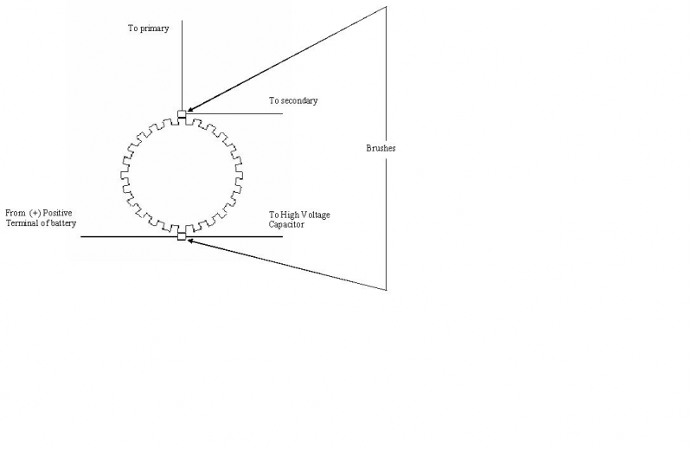
Thread Page 10

Re: Free Solid State/mechanical energy
« Reply #93 on: February 21, 2007, 01:15:49 AM »
Hello everyone,
I made a typo in one or two of my posts. The secondary is 144 inches not the primary, it is to be based on a 22.5 mm inch. This implies that this circuit will be operating at HIGH FREQUENCIES!

It's good to see that some are looking into this! The magnets are hard to find, and when you finally get them and construct this simple circuit you will understand why. Induction without any manifested magnetic field.....What!?!?!?!

There is much to be learned from this circuit! But before you attempt to construct it, study it, you may think you understand but are only fooling yourself. All of our would be teachers in this field are still cutting flux lines. Shameful.....Just ask the Merthina community in Switzerland, they know all about cutting flux lines. (side note, those disks on the Testatika have a magnetic foil taped to the surface, ever wonder why the wheels are dark colored?....Oops, cats out of the bag now!!! It's a very ingenious induction generator. I recommend trying the proof of concept on the following link, just don't forget the magnetic foil!! Sorry its in German. Flux cutting.....This is not the way to do things, this is all male! Show me nature cutting a flux line! If nature were asked what a flux line is she would probably shrug her shoulders if she had any. I will say this about the Merthina engineers, they are further along then mainstream, their machines are based on circuits of induction versus conduction. hmmmmm......

http://www.hcrs.at/TESTA.HTM

The whole world has been collectively searching for a unified field theory, this disorganized searching was then as it is at present all done in vain, the world cannot and will not find a method for unifying fields when the cause of what we call fields remains unknown. The fundamental cause of the fields awaits our discovery. Collectively we shall make this discovery when we realize through a change in our thinking assisted by experimentation, the true nature of that which we mistakenly call magnetism! This one change in our thinking will reveal to us in a few months time that which we have been searching for for hundreds if not thousands of years!!! Just say it with me "I don't know what magnetism is, what I have been taught cannot be the whole story. I desire to know the whole story!" "I don't know what electricity is, what I have been taught cannot be the whole story. I desire to know the whole story!!!" "I don't know what gravity is, what I have been taught cannot be the whole story. I desire to know the whole story!!!!"

Grumpy
We should talk, I like that you mentioned Leedskalnin. His wheel, and my magnet ring are one in the same, there is no difference in function, only in shape of magnets. Excellent investigating! Now you must try and understand how his wheel worked, you do this and you are light years ahead of the rest, and in a better position to help others. Also I like your mentioning Dr. Stefan Marinov, (electric motor without magnetic B-Field) getting warm!

Ask yourselves why Tesla only produced machines which operated at high frequencies, and high voltages!!!!! DEAD GIVEAWAY!!!! Stop thinking discharge!!! Start thinking Stress (dielectric stress maybe?!?!?!?) At the frequencies Tesla was using BACK EMF PERMIATED EVERYTHING!!!!! High frequencies solidify space, according to Tesla!!! At the voltages Tesla was using the stress (pressure) on space (aether) was ENORMOUS!!!. Patent No. 568,176 page 2, paragraph 15 reads:

"The secondary of L which constitutes the source of currents of high frequency which may be applied to many useful purposes, as for electric illumination, the operation of Crooke's tubes, or the production of high vacua."

"OR THE PRODUCTION OF HIGH VACUA!!!!!!!!"

our limited thinking has us limiting this last statement to vacuum tubes...... Friends Tesla was talking about space itself, anywhere any space can be brought to a state of high vacua!!!!!

Use the force, uh I mean field,

The BACK EMF FIELD. THE FIELD OF DREAMS!!!!!

EMF = PARAMAGNETISM
BEMF = DIAMAGNETISM

Along with the attached file you now have everything you need, so STUDY, you can construct only what you KNOW!

Regards
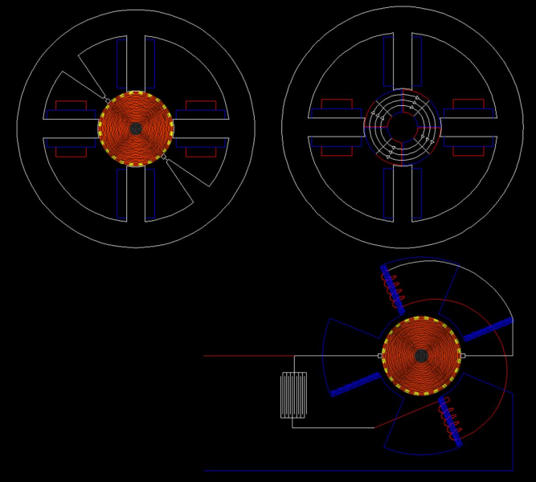

Thread Page 10
Re: Free Solid State/mechanical energy
« Reply #96 on: February 21, 2007, 09:27:15 AM »
All,
Grumpy, I like your style. Keep digging!

Charlie_v there is something that you really need to understand. I am not THEORIZING, if you don't get it, it's probably got a lot to do with your thinking. If you really want it then you must be willing to change your thinking!

That being said, please try and refrain from rebroadcasting the ideas of mainstream. They have given you nothing, they have given the world at large nothing! Your magnet arrangement is not true to nature. Instead of trying to find shortcuts try to stick to and understand the suggestions given. Had I not responded to your post many individuals would have been misled. Stick to the guidance which has been been given please.

Charlie_v, You are correct you really don't need to buy the magnets, however this is true only if you know where you can salvage them, those that you salvage must meet the standard, meaning there must be four, and they must touch and void! Your arrangement with the square magnets of various sizes would result in more then four magnets, and change the effect of this particular circuit.

The problem I see developing at present is that everyone wants to build this thing and no one wants to study!! We all know that this will result in nothing fruitful, wow, another device built, and no one understands it. Funny after typing that I see before me a sea of Tesla coils.....everyone knows how to build them, but don't understand them at all!!! In the diagram there are two Tesla coils, each with an extra coil......We must change our thinking in order to comprehend and understand!

Reason why the number of magnets is important...

Each segment centers a field which extends from the Bloch wall. The Bloch wall the point of stillness, the point where the Creator centers the created, the point between the two poles. Here it can be said that the potentials at the poles represent the total power of the neutral point, that the poles represent the neutral point divided, the neutral point, where one becomes two, and two become three. The neutral and the two extended poles.

Each segment thus has it's own potential (both the potential and frequency of what we falsely call magnetism is extremely high). If people knew how to construct circuits which functioned on the principles of induction versus conduction, from this one change an entirely new way of doing things would be born. Connecting the magnets in series is like connecting batteries in series. More batteries results in more current in the circuit, the same holds true for the magnet segments, as the two are mirrors of one another, just instead of conducting currents you are inducing fields. Through the ring we connect to the wheel work of nature!!!

Here is a universal truth, when it's meaning is understood.

"Positive charge attracts positive charge and expels negative discharge. Negative discharge repels both negative discharge and positive charge."

The Universal One

There is a current flowing within the magnet ring, a magnetic current. The ring is mounted on an aluminium core. Aluminium is paramagnetic. Paramagnetism draws paramagnetism to itself and expels diamagnetism!!!!!! Aluminium in comparison to iron doesn't concentrate the paramagnetic field. In the aluminium the field sloshes back and forth spilling diamagnetism into the circuit.

Wake up, Study, the truth has been staring us in the eyes for years!!!

Regards

Thread Page 11

Re: Free Solid State/mechanical energy
« Reply #100 on: February 21, 2007, 07:49:48 PM »
Grumpy,
I am sure you and all viewing may have noticed that details about the dimensions have been left out. This was done to force study before construction. Please don't attempt construction until you know what the outcome will be.

The magnet ring and the switch are the same diameter, if the magnet field is on the second octave 3240 (refer to previous posts) then all aspects concerning the magnets and fields must be in accordance with this. This means that the magnet dimensions must be governed by the second octave and they must resonate on the first octave. This also applies to the coils. To insure resonance on the first octave the 22.5mm/inch is used.
That being said:

3240 / 22.5mm/inch = 144mm
3240 / 24mm/inch = 135mm
135 = rpm
144 inches / 24 = 6 inches

6 inches @ 22.5mm/inch = diameter for both magnetic ring and switch. Ring has an inner diameter of 2 inches @ 22.5mm/inch. Grumpy if you can can make the magnets know this, they must be radially magnetized. It is better if you can either salvage them or buy.
Regards

Thread Page 11

Re: Free Solid State/mechanical energy
« Reply #104 on: February 22, 2007, 09:04:28 AM »
People, people, people,
Here another universal truth when understood.

"Great art is simple. My universe is great art, for it is simple.
"Great art is balanced. My universe is consummate art, for it is balanced simplicity.
"My universe is one in which many things have majestic measure; and again another many have measure to fine for the sensing.
"Yet I have not one law for the majestic things, and another for law for things which are beyond the sensing.
"I have but one law for all My opposed pairs of creating things; and that law needs but one word to spell it out, so hear Me when I say that the one word of My one law is

BALANCE

"And if man needs two words to aid him in his knowing of the workings of that law, those two words are

BALANCED INTERCHANGE

"If man still needs more words to aid his knowing of My one law, give him another one, and let those three words be

RYTHMIC BALANCED INTERCHANGE"

From the Divine Illiad

Let the above guide your thinking as you try and understand what is going on in this circuit. I love what you all are doing, I just want to remind you that your attachment to mainstream scientific teachings will stunt your growth if you are attached to them. Let go of them, think for yourselves. Free your minds of the blocks, and limitations.

Charlie_v, for some reason you just can't allow yourself to understand just how wrong mainstream science is. This saddens me my friend. It saddens me as I read your responses, your words limiting every aspect of any and everything. It saddens me that before you even attempt to comprehend what was provided you change, and manipulate the data to fit you. What a waste of time, energy, and talent! To prove this I will quote you.

"I'm pretty sure that placing a load on the rotor would cause it to stop. If not, it will be draining energy from the battery - but hopefully I'm wrong! It would be interesting if, instead of a battery, a precharge capacitor is used."

Charlie_v had you really studied the drawing, you would see that the circuit immediately changes the EMF of the battery to BEMF which goes right back into the battery, and the capacitor. Nothing lost and nothing gained. It is interesting how you wondered if this circuit could eventually be powered by a capacitor. What is a battery if not a capacitor precharged? This circuit was designed to demonstrate the following basics, as these basics form a quarter of the foundation needed to understand this technology:

1. How EMF is transformed into BEMF, how these two are the one and the same and how they differ.

2. How a battery functions in this circuit as if it is a capacitor.

3. The nature of paramagnetism, and diamagnetism.

4. How differences in potential are the cause of motion.

Charlie_v conventional science teaches that loading a motor, will slow and stop the rotor. You should ask yourself how this circuit differs from the conventional models you're familiar with. Conventional circuits are designed with field coils or permanent magnet, coil combinations placed at ninety degrees from one another, when these circuits are energized well you know what happens....I am not your teacher.....Now how does this differ from the circuit I provided? The fields are not 90 degrees out of phase, in the conventional sense. The field of the magnet ring is contained within the ring, moving at almost an instant velocity radially within the material in two directions simultaneously, however the North to South direction is dominate. This field can only be influenced by BACK EMF.

Since the field of the ring is moving at almost an infinite velocity, the wheel can be made rotate at an almost infinite velocity, construction methods being the only limiting factor. Like I said many may think they know but don't, and I can't teach you the realities, nor show them to you, all who would understand must change their thinking and see the truth for yourselves.

There is a machine which does not have moving parts which produces BEMF from EMF, using only magnets and coils. But what does this benefit anyone if no one knows why it functions.

More information about the measuring system can be had here. Don't read to much into it, as this is not needed. What I have provided is all that is needed at this point, go beyond this and you can get lost, literally! Play with the numbers as I did, and discover the synchronicities, everything is interconnected. Trust your gut, but don't stray from the path set!

http://www.themeasuringsystemofthegods.com/index.html

First Octave
1080 / 48 = 22.5
1080 / 45 = 24
1080 / 42 = 25.71428571

Second Octave
3240 / 48 = 67.5
3240 / 45 = 72
3240 / 42 = 77.1428571

3240 (second octave) / 22.5 (first octave) = 144 (coil)
3240 (second octave) / 24 (first octave) = 135 (rpm)
as coil, ring and switch are directly related

144 (first octave) / 24 (first octave) = 6 (dimension of first octave object)
If you don't get it......Study, you can construct only what you know!
Regards

Thread Page 12

Re: Free Solid State/mechanical energy
« Reply #117 on: February 24, 2007, 02:27:03 PM »
Good,
You have found the magnets, now put arrange them as I have suggested.

This will be my last post, people want to think and do what they want and I respect this. Someone was once asked if there is a solid state device based on what I have attempted to share here, my answer is yes. You must sincerely study and comprehend, and understand what was given in order that you may understand the solid state, as solid state takes us into the third and fourth octaves. Our collective understanding of electricity, magnetism, is wrong but I leave this for you all to discover for yourselves. I have been told that I speak in riddles, this is not my intention, it is next to impossible to share what I have awakened to with people who are not willing to open their minds to newer and better things. I wish all of you the best, and leave you all with your understandings, and the tip of the iceberg of mine, I leave all of you with an image of true solid state, where only an understanding of natures forces Paramagnetism (EMF), and Diamagnetism (BEMF), coils, and magnets are the only tools required to tap into the unlimited power of the universe. Soon we will understand and use this untapped power source and will be enabled to fulfil our greatest dreams. The day we collectively master diamagnetism (BEMF) will with mark the day when humanity finally remembers the techniques with which the pyramids, and other ancient megaliths were constructed, this will also mark the day when we remember how to fly!

Remember the following universal truth

"Positive charge attracts positive charge, and expels negative discharge. Negative discharge repels both negative discharge and positive charge."
The Universal One
Positive Charge = Paramagnetism = EMF
Negative Discharge = Diamagnetism = BEMF
Regards
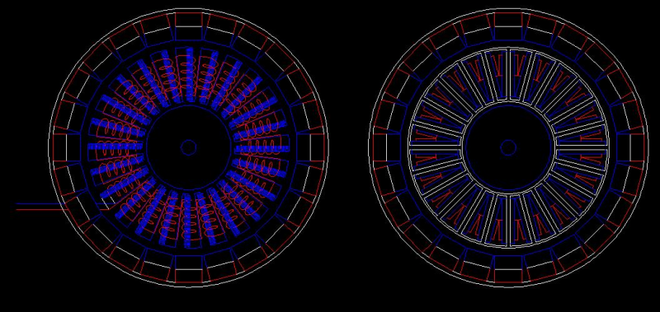

Thread Page 14
Re: Free Solid State/mechanical energy
« Reply #134 on: February 27, 2007, 10:51:34 AM »
Reply with quoteQuote
Hello again,
It sucks when you are forced to eat your words, this happens when someone takes your message and twists it to a point where all signs of the original meaning is lost, this has happened when barabosi posted that modification to my drawing. I said I would not post again until progress was being made, people began thinking differently. I notice a change in the thinking of some however this is still very limited, but acceptable, as any change is positive. Barabosi's interpretation of my drawing is 100% wrong! Do not follow this line of thinking, if and when you do, you will find that you have nothing new, you will end up with what is already known and understood. I repeat ignore the last interpretation of my drawing by barbosi. No offense barabosi.
Mainstream teaching has perverted our understanding of imlosion! EMF is a means. EMF is going against the current, BEMF is going with it. The question which should be asked is where is the BEMF returning to? There is only one answer. The VOID!
Regards

Thread Page 15
Re: Free Solid State/mechanical energy
« Reply #142 on: February 27, 2007, 10:20:21 PM »
Hello,
This should have been obvious! The primary coils are connected in series. The secondary coils are connected in series. One positive pole of the primary and secondary coils are connected in parallel. An EMF leaves the battery and is not allowed to return. Many of you are going to argue this and say that the current returns to the battery via the secondary winding. You would be wrong! Why? 1. Refer to quotes from Tesla patents back on page 7. 2. Currents behave differently when they are pulsed! Study how they behave, how they flow.

Science would have us believe that electrons are flowing through and or around a conductor, when in fact there is no electron flow, not because I say that there are no electrons, when we begin to understand fields we begin to understand that the fields, not the electrons are the true workers! A complete understanding of fields (EMF, and BEMF) explains many things heretofore unexplainable.

If any of you are familiar with cavitation then you have yet another example of what is going on in this circuit. In the given example the EMF is the flow of the field in one direction, opening the circuit abruptly causes a cavitation of this substance, this is a hint as to the fluid nature of the fields (Tesla mentioned this)! There are other things which go along with this which will not be mentioned yet.

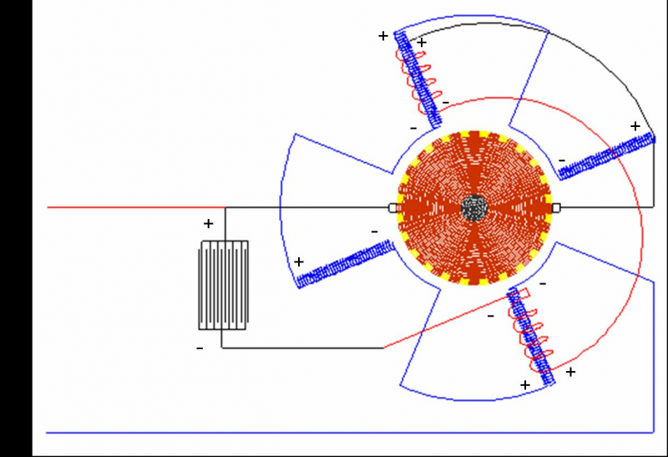
BEMF is the the field returning to the source (IMPLOSION!!!). The source is the VOID!Flow returning to the source is not restricted, nor resisted it is assisted, and self organizing in it's effort to return. It is said that a magnetic fields collapse, but this has never been adquately explained. BEMF is explosive radiation, the result of rapidly cavitating a flowing field. Collapse in this since does not mean in on itself, but outward towards and into the void, as I said currents behave differently when they are pulsed, become familiar with this difference. Flux lines are curved, curvature ends in the Void.
Regards

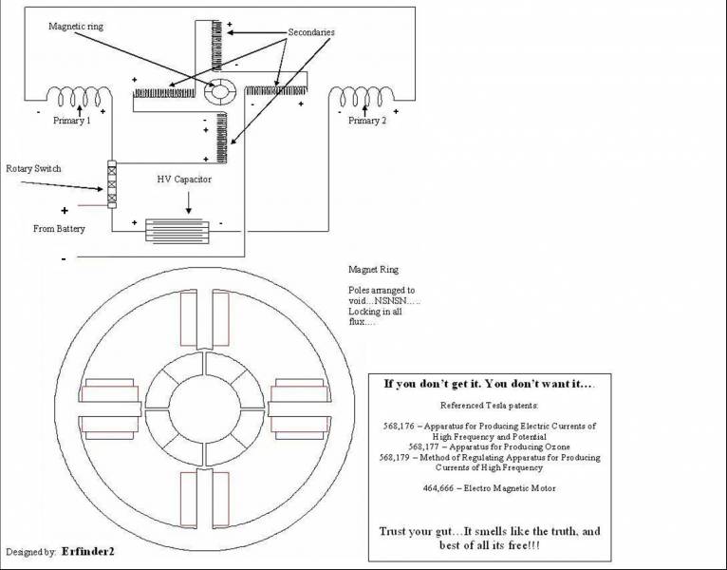

Thread Page 16
Re: Free Solid State/mechanical energy
« Reply #150 on: February 28, 2007, 10:46:56 AM »
Reply with quoteQuote
charlie_v,
Removing the ring will not change the relationship that the coils, battery and capacitor form with one another, nor will it effect how the circuit functions overall, as we have a void in the battery! How? First it must be understood that the void is the point which exists between 180 degree opposed conditions. In this case it is the point between EMF, and BEMF. What we take out the source we cannot put back in in the same form, meaning when we take an EMF from the battery, we can only put a BEMF back in the battery. When we transform the form of that which we removed into its opposite we can place as much of this back into our source as we desire, limited only by the capacity of the source. This is lesson one!

This particular configuration demonstrates that the fields are in motion, and that they attract that which is like itself unto itself, while simultaneously expelling it's opposite. What has up until now not been fully understood is that the expulsion of diamagnetism is the real cause of motion in present day motors. Negative discharge repels both negative discharge and positive charge.

In the new standard we find that fields can produce motion without force when we design our machines to follow the field flow back to the void (implosion technology). It is as if the magnet ring is a wheel being carried by the currents of a swiftly moving stream.

The charging of the battery and capacitor have nothing to do with the ring, the ring does not charge anything. The battery is the source, it is the void. Later it will become clear that void acts on void! We must study the battery, understand how it is the void, how EMF leaves it, and is transformed into BEMF by the coils, and how the BEMF returns to the void in the battery.

*** Note ***
Please take note of the fact that I am to the best of my ability trying to use a language everyone can understand. One where people of many different backgrounds may participate in this discussion. (Attracting that which is like myself unto myself, and expelling mainstream! One must also live the principles!) Those of you who are serious about this should try to do the same, I thought like most here some time ago, I had to change my thinking. When you do this (change your thinking) you will realize that you are losing nothing, you will gain a new understanding of how things really work and then can apply what you already know to the new way of doing things. Before this can take place however we must have a immovable foundation, this we don't have at present. Don't demand to know more than you are capable of understanding.

Every aspect of this is important, the machine is a tool which demonstrates certain principles, if you cannot understand the principles then you should not build the machine! This is the point I have been trying to make since I first began posting. That being said, FORGET ELECTRONS!!! VECTORS, and all the other mainstream blah blah blah which you all keep bringing in, at present they do not fit, they will later, but we need to establish the foundation first, this is the reason that I decided to leave the last time, as people think that I am giving a theory and are trying to figure it out by going all mainstream on me and everyone else. Pay close attention to the following words.

THIS IS NOT A THEORY!!! THESE ARE THE PRINCIPLES UPON WHICH THE UNIVERSE IS FOUNDED AND MAINTAINED!!!

Don't believe me like a blind follower, study and discover these truths for yourselves!

If you all want me to stay around then you must at least here on this thread stop using the mainstream view when looking reviewing this material, this is the trade off, I will not argue with anyone nor get involved in debates as the truth needs no verification when it is known!
*** End Note ***

Grumpy,
Centripetal motion (EMF) gives birth to centrifugal (BEMF)! BEMF is Centrifugal, you cannot have centrifugal motion without centripetal. If you do come up with a way you will be the first! Instead of trying to get BEMF alone we should concentrate on the relationship EMF has to BEMF, and how they are used to produce implosion.

I know what all of you want! But I will not give it to you, as you don't need me to give it to you. Soon some of you will begin to understand some of the things which have been said so far, and will be glad that I let you think for yourself and not spoon feed you what you wanted to hear. All here are GENIUS don't let mainstream fool you. The same void which centers this machine centers us! Trust your gut, study, comprehend, understand and then build!
Regards

Thread Page 16
Re: Free Solid State/mechanical energy
« Reply #158 on: February 28, 2007, 05:39:55 PM »
***** Books *****

- Walter and Lao Russell -
Home Study Course
A Course In Cosmic Consciousness Transformational Study of Universal Law, Natural Science, and Living Philosophy

The Secret of Light
The Message of the Divine Illiad Vol.I
The Message of the Divine Illiad Vol.II
A New Concept of the Unverse
The Russell Genero-Radiative Concept
The Universal One
Atomic Suicide
God Will Work With You But Not For You
Why You Cannot Die
Love

- Schauberger -
The Vortex Key To Future Science
Hidden Nature The Startling Insights of Viktor Schauberger
Living Water
Living Energies
The Water Wizard
Nature as Teacher
The Fertile Earth
The Energy Evolution
Unsere Sinnlose Arbeit - German
Viktor Schauberger Das Wesen des Wassers - German

- Schappeller -
The Physics of the Primary State of Matter

- Keely -
Keely and His Discoveries
Universal Laws Never Before Revealed: Keely's Secrets
The Physics of Love The Ultimate Universal Laws

- Tesla -
Colorado Springs Notes
Nikola Tesla Collected Articles and Lectures Vol.I
Nikola Tesla Collected Articles and Lectures Vol.II
Inventions, Reasearches and Writings of Nikola Tesla

All Patents
Other

Secret of Life
The Lakhovsky Multiple Wave Oscillator Handbook
The Emerald Tablet
Magnetic Current
Joseph H. Cater The Awsome Life Force
Ignition Equipment
The Voice Of The Crystal
Old Time Secrets of Making Permanent Magnets
A.D. Moore's Electrostatics
Earth Energy
Paramagnetism

Regards

Thread Page 17
Re: Free Solid State/mechanical energy
« Reply #162 on: March 01, 2007, 05:42:13 PM »
Charlie,
Quote from: Charlie_V on March 01, 2007, 12:55:28 AM
Since the magnetic ring does not effect how the circuit functions, why do we need a specific number of magnets (or any magnets at all)?

Good questions! The answers are very, very long, and will not be presented yet. However I will try to give you something to think about. Try to look beyond the physical, the material. It is not the number of magnets which is important, what is important is the number of nodes that are formed when North and south void! The number of nodes is important!

There is a rhythmic interchange between North and South where north enters the void and emerges as south and south enters the void and emerges as north. The change over is one fluid motion! The field is spiraling forward right to left, and suddenly the flow changes its flow direction from right to left to left to right without slowing down or stopping!

Quote from: Charlie_V on March 01, 2007, 12:55:28 AM
How would the octave equations change if you removed the magnetic ring?

They don't...

Barabosi,
Remember that this circuit is pulsed, and because it is pulsed EMF and BEMF behave differently then if they were simply alternated. The same thing that happens when you suddenly shut a valve on flowing water is happening here!!! The only difference is that the field flows outside of the conductor. To the fields the conductor is just a point in space. We must see the conductor as the fields sees the conductor. Where does the change from EMF to BEMF happen in this circuit? In a pulsing circuit such as this the conductor simulates the VOID!!!
Regards
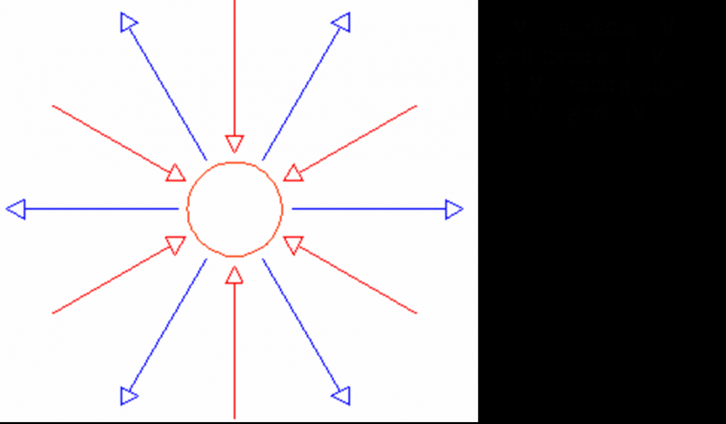

Thread Page 17

Re: Free Solid State/mechanical energy
« Reply #169 on: March 03, 2007, 05:35:42 PM »
Barabosi,
At present more then enough information about EMF and BEMF has been presented. More detailed information will be presented at a later date.

Quote from: barbosi on March 03, 2007, 04:06:05 PM
I would like to ask you though:
When you say there are two circuits (1 primary and two secondaries each) in parallel, that means the connection is a "node" (in sense of wave not electric)?

No. Only series connections produce nodes. Voids.

Quote from: barbosi on March 03, 2007, 04:06:05 PM
Second. numer 3 seams to have a great significance (not only 2 as opposed energies), it appears to be the important neutral. How is this related to VOID? Is this the VOID? If the answer is somehow complex, could you please point to a certain reference reading material? I feel this is important because in vedic mathematics there are 3 circles with 360 degrees and lenght 360 each witch will give 1080 the famous number. also the way the Octave is defined is in relation of 3 (=frecquency+2*frecquency ?) Just playing with numbers....

Neutral = VOID. The problem is our present understanding of these two words!!!

I recommend all take one year and take this course!!!!!!!!!!

Universal Law, Natural Science, and Living Philosophy. Originally written by the University founders, Walter and Lao Russell, A Course in Cosmic Consciousness

In truth this course takes a life time to complete, but one year is all that is required to help one open up to the truths of nature. Unfortunately this course is expensive! Very expensive.....

See for yourselves......

http://www.philosophy.org/index.php?page=shop.product_details&flypage=shop.flypage&product_id=139&category_id=3&manufacturer_id=0&option=com_virtuemart&Itemid=26

This is not what the authors of this material had in mind for this course, it originaly sold for $50.....Shameful what they are asking for this course now!!! I am not saying buy this course, I am saying seek it out, and when you find it, take the year to complete it. Someone said that we need to start on the same sheet of music, and this is how I recommend we do it.
Regards

Thread Page 18

Re: Free Solid State/mechanical energy
« Reply #179 on: March 18, 2007, 05:24:18 PM »
Hello,
There are eight void points! Four are created when the magnets are brought together, and four already exist within the magnets themselves!

nat1971a exellent reasearching keep it up!
Regards

Thread Page 20

Re: Free Solid State/mechanical energy
« Reply #191 on: March 20, 2007, 08:43:52 PM »
Barbosi,
Sorry but no what you have demonstrated cannot replace what I have described, and the reason why this is so you will find in examining a permanent magnet! Thinking up short cuts will not lead you to understanding what I have presented. Please try to stick to the path set even if you believe it is complete rubbish, stick to it or leave it alone, as you do not want it!

There is a reason for the number of magnets used. The magnet ring is arranged to where there are eight void points. We must learn to be more observant in order that we may discover what happens in the void. Let me help.

The void represents the point where centripetal motion becomes centrifugal motion. This happens in one fluid motion! What happens when you are spinning in one direction at the speed of light and you instantaneously spin at full speed in the opposite direction? What would happen to you if you tried this in your car? Don't tell me that this isn't possible, as it is fact!

What causes the field lines of a permanent magnet to expand outward?

Why is the point of maximum expansion of the field lines at the equator?

How does the flux enter and exit the permanent magnet?

What is the difference between a man made permanent magnet and those constructed by nature?

What is the nature of a flux line?

If you can answer these questions right now you are one step closer to understanding some of the freaky stuff I have presented here. The majority of researchers here are as I was in my beginnings blinded by the quest for free energy.

See for yourself that there is no such thing once you fully understand all that is going on in nature. Electricity is not a cause it is an effect, the cause of electricity grows like trees! Take a walk through the forests and look at the trees and see your electricity before it manifests as electricity. If your device sparks, or warms in the slightest degree its not in harmony with nature. The generator which powers nature is infinitely larger than the largest thing we can think of, and it runs cold and quiet! No moving part! Why? Because the only thing that needs to move are the fields!

Your efforts to think outside of the box will reward you. Don't give up!
Regards

Thread Page 20

Re: Free Solid State/mechanical energy
« Reply #197 on: March 22, 2007, 12:13:25 AM »
All,
You wanted it now here it is, no one will be able to get it to work because no one has studied!!! You only need magnets and coils!!! That's it!!! No timing circuits, no caps, nothing, just magnets and coils! You must learn about pulsing and all of the other stuff that I brought up so that you can understand the behavior of the fields, as they are pulsing!!! In this solid state apparatus is the true secret of the Searl Generator, they can say what they want if you know what you are looking for you will see it! I will not say anymore about that!!!

Welcome to the VOID!!!

P.S. Before you ask, there are no moving parts. Everything is stationary......

nat1971a,

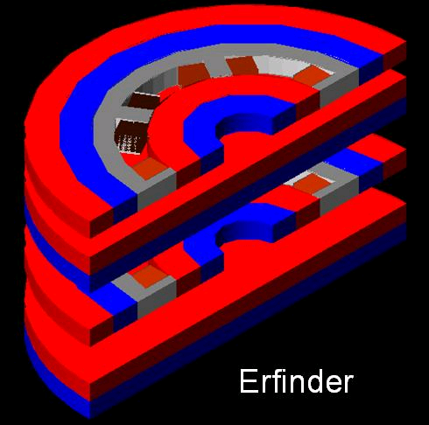
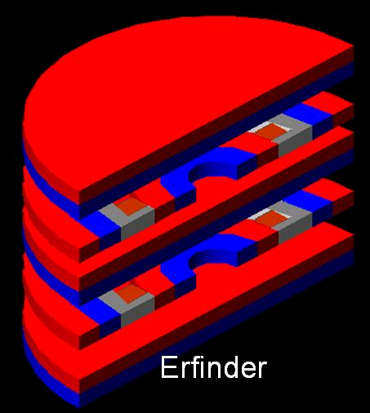
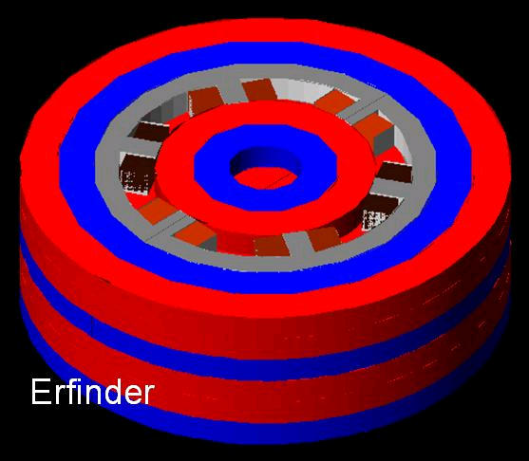
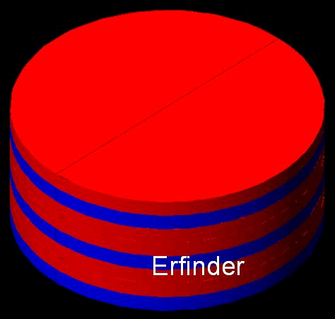
Sit back and relax take in a deep breath and exhale it slowly, and think about what Tesla could have meant when he said closed on themselves (referring to the coils in patent no. 464,666). If you get stuck, as I am sure you might, go pay Ed Leedskalnin a quick visit. Study his Perpetual Motion Holder, closed upon themselves indeed!!!
Regards

Thread Page 21

Re: Free Solid State/mechanical energy
« Reply #201 on: March 22, 2007, 09:35:26 AM »
Sorry Tao,
The FEMM image is incorrect. The secret of this device is in knowing how to make flux behave. Before this can be done one must know what flux is! Tao your FEMM image is not true to what I have presented. It should be completely obvious how the magnets are magnetized. One type of magnet used in this machine is modeled after the magnets of nature, and the other is the type which all are familiar. Get back to nature, her method of generating magnets have never been studied!
Regards

nat1971a,

The Leedskalnin generator can produce AC, but it not an AC generator! Focus on his Perpetual Motion Holder, and you will find that his generator is a flower, who's petals are a series of Perpetual motion holders in the shape of V-shaped permanent magnets! The key is the void.

Why do flux lines expand away from the equator of a magnet?

What is happening at the equator?

When you know this you will have found a truth more profound than any to date!!!
Regards

Thread Page 21

Re: Free Solid State/mechanical energy
« Reply #207 on: March 22, 2007, 06:25:48 PM »
Nope not having second thoughts, I'm just not sure if I should put too much info out there to fast.....Everyone learns, at their own speed, and I am trying to respect this. Just blasting you all with this stuff is not going to help you understand it any faster, this is the reason why I took the picture back. In the days and weeks to come maybe I will post it.
Regards

Thread Page 22

Re: Free Solid State/mechanical energy
« Reply #214 on: March 22, 2007, 10:31:51 PM »
Hello,
You all are definitely on the right track, and I applaud you for bringing Schauberger into the mix, as he is one of the main men on my list of people who had something to profound to say.

nat,
Fig. 1 is not accurate, but I am sure you know this, the flux will take the path of least resistance, the air resists the flow of the substanc we mistakenly call magnetism, therefore the flux will immediately seek out either the next available piece of metal or magnet pole! You are very close in your second image. You must work harder in understanding how the flux enters the magnet and how the flux exits the magnet. You are correct in thinking that there are two counter rotating fields within the ring as there are, just remember that when the fields enter the void they exchange roles, which means that there is only one field which is divded into two! These counter rotating flows enter and exit the eight void points as they circulate through the ring.

barbosi,
I applaud your efforts. The image you found threw me for a loop when I saw it for the first time as well, and later it got even more confusing as I discovered that you must have a flow which is going in two directions at the same time! This is not happening in that image. In the image taken from the Living Energies book the flow is one polarity and one uniform movement from one end to the other. In order for the field to move the two opposite polarities must be facing one another, they must pull over and through one another.
Regards

Thread Page 22

Re: Free Solid State/mechanical energy
« Reply #219 on: March 23, 2007, 02:35:39 PM »
nat,
Nice drawing! One thing though, the flux lines do not curve around and back forming a flower like you have indicated in your drawing. When poles void the flux curvature stops! Our proof of this is can be seen when two opposite magnet poles are allowed to touch and void, the flux at that point no longer manifests externally´, flux curves around this point. Once the ring is voided completely something very unexpected happens. North, South, and Void are made to manifest on one plane! The flux lines travel like spiraling rays into and out of the ring!
Regards
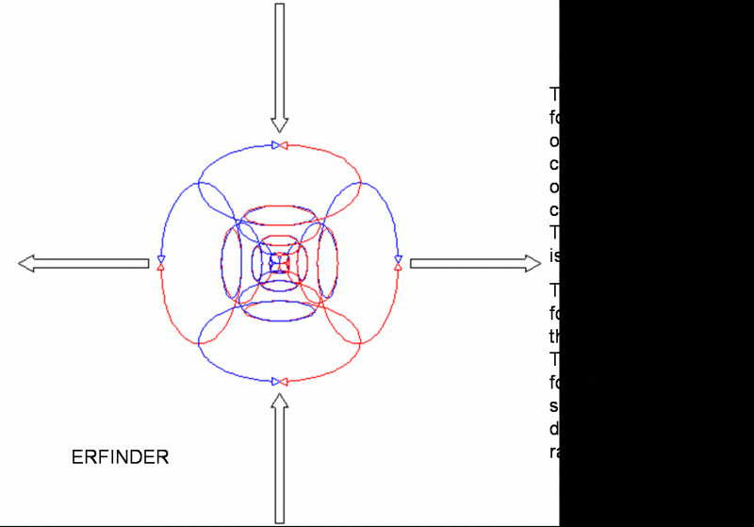

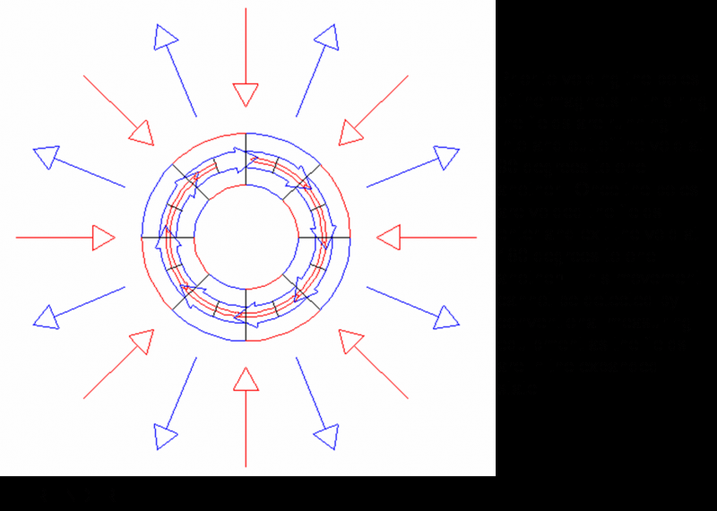

Thread Page 23

Re: Free Solid State/mechanical energy
« Reply #223 on: March 23, 2007, 06:42:06 PM »
Barbosi,
Quote from: barbosi on March 23, 2007, 04:44:36 PM
1. What is the nature of North and what is the nature of South?

My friend the answer to this question is more complicated. It took me two years to understand it, thinking only on it day and night and you want me to sum it up for you in a sentence or two! I will give it my best, but many of you will not like the anwser!

Let the truth be told, there is only one substance. That substance is Mind. Within Mind exists all knowledge and power. Mind is Still Magnetic Light. All idea in Mind is complete in it's entirety, it is however without form. Mind has but one desire and this desire is to create bodies for it's ideas. It is enabled to do this through thinking. The thinking process of Mind is a dual process, Concentration, and Decentration. Concentration represents a seeming moving away from ones center in Mind. Decentration represents a relaxing from thinking and return to ones center in Mind, this process is expressed electrically. That being said the natures of north and south should now be apparent. For too long the Creator has been stripped out of the equation, no longer!

Quote from: barbosi on March 23, 2007, 04:44:36 PM
2. From fig. 1 Northe and South are two whirlpools bracing eachother in both gravitive and radiative manifestation?

It must be understood that a magnet has four poles, not two! Two poles charge the magnet, and two poles discharge it! There are therefore four vortex! Two of them contract towards the center expressing the gravitive, or concentrative power of Mind Thinking, and the other two expand from the center expressing the radiative, or decentrative power of Mind Thinking. This is demonstrated in the diagram.

Quote from: barbosi on March 23, 2007, 04:44:36 PM
3. While the funnels are shown in 3D, the axis given by the whirlpools are represented in the same plane. The radiative manifestation (outward whirlpools) shouldn't be spatial distributed, all around "Bloch wall"?

To answer this question I give you the following exercise. Imagine you are standing on the top of a pyramid. From your position you are enabled to see all within your field of view. Imagine that your field of vision opens up and you are able to see 360 degrees from this position. When you do this imagine 5 more pyramids have just appeared, they all combine with the one you are standing on top of to form a cube, and you are perfectly centered amongst all of them as you are on the apex of all of them. This is the position from which the Bloch Wall occupies, it is from this position that the Bloch wall views the four vortex. From your postion things contract towards you and expand away from you.

Your last question you don't need me to answer as you know very well what happens when a magnet is broken, and in time you will know why.

I changed my post a bit because I was not direct enough, and at the same time I felt that the my attitude reflected a bit of impatients. That was the reason for the change. As far as reading material goes, you have all that you need posted here, and on the CD I sent you! You don't need anymore then that. Give yourself time, the anwsers you seek will unfold if your desire for it to unfold is strong enough.
Regards

Thread Page 24

Re: Free Solid State/mechanical energy
« Reply #234 on: March 28, 2007, 09:15:37 AM »
Hello
You all are really making this difficult! I may have been in error in my describing the magnets initially, but from the images provided it should have been obvious. Yes after looking back I said that the magnets were radially magnetized. This was in error. The magnets are Axially Magnetized! The following image should clear things up. If not then......just give up! Just kidding! Use common sense...There is only one way to put the magnets together and make the poles disappear! Come on!!! These magnets are magnetized just like the cube magnets you all are playing around with they are just u shaped!!!!! Work with me!

You all are so interested in finding the right magnets. You all are missing the point! And that is how flux behaves when the poles void, how the flux moves, and how we interact with this flux. This is not a free energy machine, it is a teaching tool, it was designed to condition the mind to recognize certain fundamental truths which have been up till now overlooked! When all is understood all that one would need to build what you all collectively call free energy device are magnets and coils! Try as you may without first having the fundamentals burned into your soul, you will fail!

The reason that I am making this difficult, or not just spelling it out for all, is because all have the wrong idea, no matter how high your education or background goes! Therefore all who desire this dream to become a reality must begin at the beginning. I asked a guy to describe to me how I should go about making a homemade chocolate cake. He told me to go to the store down blah blah isle, and grab blah blah brand, go home and follow the instructions! This was his same approach to free energy and levitation! The people want a ready made answer, I will not cheat you! You can do it. Everyone here is a genius! Believe it!

So that being said chill with the wild goose chases, searching for the exotic multipole magnets, they are not needed. How can anyone expect to work with a multipole magnet and the simple dipoles are not fundamentally understood?!

Just relax, if you have been reading and rereading this stuff, then by now you already know the anwsers. Start believing you do, and then demonstrate it by talking amongst yourselves about what is happening in the machine instead of which magnets are the right ones! As soon as I see effort on your parts in this direction, I will give the next piece of the puzzle. I do remember saying comprehension comes before construction! You cannot construct what you do not understand! Talk amongst yourselves about the fundamentals, if you all take one step collectively I will take two!!

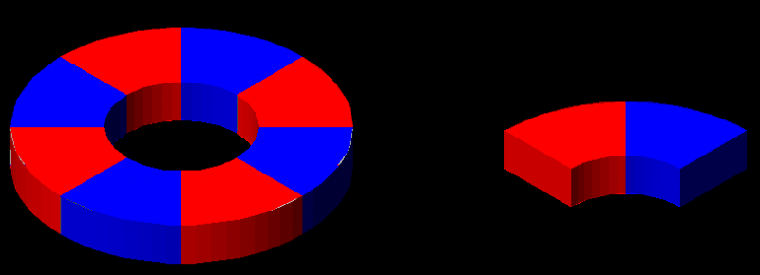
Regards

Thread Page 25

Re: Free Solid State/mechanical energy
« Reply #245 on: April 01, 2007, 04:33:33 PM »
Hello,
This does not look like progress! It's like i feared. Everyone wants this stuff spelled out for them. Things have escalated on my end. I have things that I would like to put out into the open, but no one here appears to be willing to go the extra mile and think for yourselves. Free energy is baloney, and anyone who promises you that is full of it. I have made no such promises. What I desire to give is true power! The very same used by all. The energy working behind the scenes! But I cannot do this with out you all putting forth some effort.

I chose this forum to put out this information because money is not a motivating factor with the subscribers here, and people from all over the world pass through here. The majority here are looking for anwsers, looking for a way to get off the grid, and maybe, just maybe conquer gravity. You can accomplish all of this it is far easier than all of you could possibly imagine! But before you can play you must understand the ground rules, you must become familiar with nature's laws, at present you all are following man's laws!

I will put it like this. It is known that aluminium is paramagnetic, but so is basalt stone! There are many paramagnetic, and diamagnetic stones! But here is the killer, not only are these stones either paramagnetic or diamagnetic, they are at the same time dielectric materials, try to get that with a man made material cheap! Rocks are FREE!!! You all just don't get it! The ancients weren't stupid! We are! Once you understand magnetism, and the void, you can float stones, people, cars, buildings, and the list goes on and on! A stone ground into a fine powder mixed with a binding agent, and then sun dried makes a perfect new age surf board. You only require the proper quality magnetic fields to ride on! No power supply just magnets and coils! Magnets and coils!!!

This is it. If you want to move on, you know how to reach me.
Regards

Thread Page 25
Re: Free Solid State/mechanical energy
« Reply #248 on: April 01, 2007, 09:42:01 PM »
Tao,
Quote from: tao on April 01, 2007, 07:12:18 PM
From you writing and my readings, I see the VOID as the state of pure STILLNESS in the universe. It is where everyTHING emanates from and where everyTHING returns to. EveryTHING that comes from the VOID(which is everything) WILL return to this VOID.

You are both right and wrong! I have been describing the void but have yet to outright say what it is. Stillness is just that stillness. The voided conditions we manifest with the magnets or in other examples are how we simulate the void! We cannot recreate stillness, as our reality is one of motion. Just remember that as long as you have an equator you have polarity, regardless of where the poles are located! You are right when you say that everything enters and exits the void, but this has a deeper meaning! Try and see if you can comprehend how motion can simulate stillness!

Quote from: tao on April 01, 2007, 07:12:18 PM
The VOID is the ONE constant, like what the Taoist's call the TAO. In our world everyTHING exists in POLARITY, this is because everyTHING that comes from the VOID must do so IN OPPOSITES, so that there is ALWAYS BALANCE.

If there was perfect balance nothing would move! The purpose of the two opposites is so that a rhythmic balanced interchange can take place. One polarity enters the void and emerges as its opposite, and vice versa. Forever.

Quote from: tao on April 01, 2007, 07:12:18 PM
This is why you(Erfinder) are constantly saying there is no free energy, because under this understanding, there can't be! There can only be a balance of energies TO AND FROM THE VOID. But, that doesn't mean that we can't USE these balanced situations to our advantages to provide us with SEEMINGLY free energy...

I say that there is no such thing as free energy because energy has not been adequately defined! I say there is no such thing as free energy because we say that free energy is free electricity. We are being mislead into thinking that radiant energy is the free energy! It has never crossed anyone's mind that radiation = explosion! An explosion cannot exist of and by itself, it had a cause, and that cause is implosion! We have become very good at producing effects, but are still in the dark as to the causes of things! We are only using one half of the electricity we are producing! The hot side! The cold side we are throwing in the garbage! Those who have jumped on the radiant energy band wagon are now using the cold side of electricity, and are throwing the hot side in the garbage! Now we have those who send the hot side one way in the circuit and the cold side the other way. This is better, but still not what nature had in mind! Hot and Cold are to be projected at one another, through one another, they must be allowed to void one another! This is what nature intended! This neutral energy is the energy which powers nature!

Quote from: tao on April 01, 2007, 07:12:18 PM
From this understanding, things like tornados or vortexes or magnetic fields, all these things seems so one dimensional. But, adhering to the VOID way of things, each of those things are appearing in our 'world' in A BALANCED STATE. Sure, a tornado seems violent, but it's existance could only be possible if there was a higher order BALANCE involved.

The void must be understood, and its simulation in our reality comprehended! The one is immovable and the other is motion! Once the difference is recognized and understood all things and I mean all things can be known! As all things are governed by the one!

Thread Page 26

Re: Free Solid State/mechanical energy
« Reply #259 on: April 02, 2007, 09:26:21 PM »
Tao,
I don't know what you want me to say. This person is wasting his/her time! They are still trying to get either AC, or DC. The goal is to get away from both, to get back to the neutral currents used by nature! I would not continue in this direction, but if you must then you must.

Leedskalnin has a device which is far superior to this one! He called it the Perpetual Motion Holder! Study it, and see this persons short comings! Leedskalnin connected the coils of his ring to a car battery for about 2 seconds (and that's it just 2 seconds!!!), and produced a magnetic force which could hold 30 lbs. 1 battery, 2 coils 1 bar bent into a U shape with a removable cross bar. Simply amazing! Not only this but he demonstrated that he could get the electricity back out!!!!!!!

The efforts of Leedskalnin will soon amaze the world, soon his secret will be known by all, through the efforts of all who seek to understand how he accomplished all that he did! I will help, as I understand, but I will not do your work for you, no one did my work for me! Through your combined efforts we will one day all be on the same sheet of music singing the same song, and what a song it shall be!!!
I have faith in your efforts!
Regards

Thread Page 29

Re: Free Solid State/mechanical energy
« Reply #288 on: April 05, 2007, 06:31:37 PM »
Barbosi,
Quote from: barbosi on April 05, 2007, 04:06:21 PM
I think the shape is to simplistic hence wrong.

"Great art is simple. My universe is great art, for it is simple.
"Great art is balanced. My universe is consummate art, for it is balanced simplicity.
"My universe is one in which many things have majestic measure; and again another many have measure too fine for sensing.
"Yet I have not one law for majestic things, and another law for things which are beyond the sensing.
"I have but one law for all My opposed pairs of creating things; and that law needs but one word to spell it out, so hear Me when I say that the one word of My one law is

BALANCE
"And if man needs two words to aid him in his knowing of the workings of that law, those two words are
BALANCED INTERCHANGE
"If man still needs more words to aid his knowing of My one law, give to him another one, and let those three words be
RHYTHMIC BALANCED INTERCHANGE"
From the Divine Iliad
By: Walter Russell
Barbosi, the attached image alone presents more truth then you can possibly imagine! Within it is the meaning of the ancient axiom: "As above so below. So below as above." Study it and know truth!

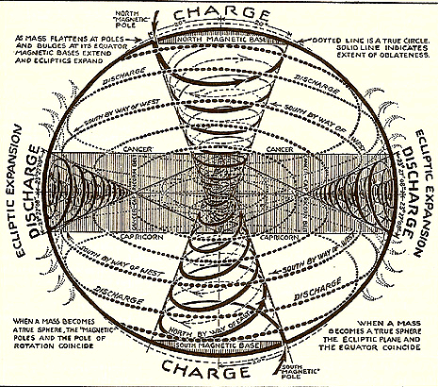

Thread Page 35
Re: Free Solid State/mechanical energy
« Reply #342 on: April 10, 2007, 06:49:17 AM »
Hello All,
I have said it once and I will say it again, you can only build what you understand! I will not tell you what you want to hear! Did you build it is your question, I will tell you no, and mean it! What is gained by building and testing, if the fundamentals you are basing the functioning of the machine on are WRONG! Why should I tell you of my success if I cannot convey to you how you too can be successful, your success is governed by your being able to comprehend and copy nature, not through experimentation! To experiment means you have no idea what you are doing, from the very beginning you are telling yourself that you hope for this or that outcome. It is always hit or miss. Does no one want to know first? To see a completed device, and all of its inner workings in your mind so clearly that all you have to do is go down to the local hardware store pick up the parts you need, return to your basement lab and construct it? This is my desire for you all! I have what I want! Your negative comments don't effect me. It is ignorance which makes us say some of the things that we say! Ignorance of nature's ways, nature's laws! You all would test me, and as usual in these situations I give you yet another gift!

Think for yourselves! Don't listen to them when they say you must experiment! Nature doesn't experiment, if she did your lives would be a living hell!!!

Ed mentioned Sweet Sixteen yet no one understands what this means. This is what it means.

16 X 16 = 256 / 2
= 128 / 2
= 64 / 2
= 32 / 2
= 16 / 2
= 8 / 2

Sweet Sixteen was an indicator that we needed to do the above math, but why? It is clear that the result we end up with do not parallel with what I have already stated, but when you realize that the Tesla Alternator had 16 magnets and Ed's generator has 24, the next step is to do the same thing with the number 24.

24 X 24 = 576 / 2
= 288 / 2
= 144 / 2
= 72 / 2
= 36 / 2
= 18 / 2
= 9 / 2

Spoon feeding is not my thing! If just 10 of you could begin to comprehend the insights I have brought to this thread, this discussion would go around the world overnight, this would attract others who are further along in their development. Again you are given the number 144. A harmonic of 432. 432/144. 432 is the square root of the true speed of light 186624! Experimenting to find this relationship could result in 5 to 10 years of research! Why? Because the mind is focused on results of an experiment (effect)and not on knowledge of cause!
Regards

Thread Page 37

Re: Free Solid State/mechanical energy
« Reply #360 on: April 13, 2007, 09:17:46 PM »
Hello All,
I think you all are doing great, however I see a problem, I presented you all with too much information!!! This problem must immediately be solved because if you all are motivated to continue in the direction you are heading in no real progress will be made, and this would be tragic, as so much effort has already gone into this!

I have started a small website, and even though it goes against my better judgement I have decided to begin at the beginning! This will be a very slow process, as many many things need to be covered. It is my desire that all who are viewing this can begin on the same page.

There will be a forum but it will not run like this one has. It will be organized, I will make statements, and all who wish to respond and or ask questions may do so. I will not entertain the theories and or laws of man, as they have only given us illusions of comfort, and disregarded the governing role of nature. That being said please understand that the laws of nature are the focus! As a warning certain aspects of this will turn some of you off as the core of it is the Creator! This would have become apparent had I continued posting here about the void.

I believe I have said enough.....I look forward to exchanging with some of you on my turf. I would recommend that you all keep this tread going as some really good information is here! I am new to web hosting so things will be very very very slow in the beginning, so please be patient with me.

http://www.freewebs.com/walter-russell-effect/
Regards

Thread Page 38

Re: Free Solid State/mechanical energy
« Reply #379 on: April 16, 2007, 08:11:44 PM »
Hello
I have turned the forum off for now, so do not try and log in as it will not allow you access. I will activate it when I feel you all have had enough time to examine the patent. Please understand that this must happen in this manner. If not you will be lost, and all of your efforts in vain! Now is the time for anwsers, and if you want them then you must put forth more effort then you have ever thought possible of yourself, and on top of this you must be patient!

What we are going to discuss is going to shock you, not because it is something that you don't know, but because you already know all about it! The thing that has kept you blind of the truth for so long is your base! Try building a house on quicksand or water and you will know what I mean! The same applies to what you are doing now in the arena of free energy. I want you to be prepared, I want you all to have a real foundation, the foundation! So take the time and prepare yourselves, read and reread the material. If it helps treat the patent as if it were a nursery rhyme! Repeat it over and over in your mind until you know it by heart. The meaning is irrelevant at this point! I want you all to see just how easy it is to think you know and overlook the obvious, complicate the simple this is what they taught you!

I will post a message on this forum when my forum is open and discussions commence.

zepharim

It is individuals like you that make this game that we play fun!!! YOU ROCK!!! Keep spreading the LOVE!!!
Regards

Thread Page 41

Re: Free Solid State/mechanical energy
« Reply #400 on: April 18, 2007, 08:15:59 PM »
Hello All,
I see much discussion going on, but not on the subject which matters most...The first patent! I know how hard to stay on target. It is very easy to get caught up and or side tracked, but you must try and stay focused. It has been three days now and I wanted to begin discussions. I say wanted because after viewing the last few posts I believe you all need a day or two to talk amongst yourselves about the subject at hand. Make no mistake; I have yet to see one post from anyone yet which would indicate to me that discussions should begin. As you all know or should know, Tesla was against mainstream! He spoke using their language because he wanted to share his understanding with them! He wanted to give what he knew to the world. This knowledge is once again slowly making its way back into the lime light. If you want it you have to think for yourself!

What you call magnetism is in reality electricity! How? What? Impossible!!! I say again magnetism and electricity are one in the same! This would be common knowledge if scientists understood what a flux line is, and from what it extends! Before we are finished you will know exactly what a flux line is, and where it comes from! I cannot tell you right at this second as it would mean absolutely nothing to you.

We have been taught that static electricity is useless, and that the force we call magnetism is the glue of the atoms and molecules. This is hogwash! Static electricity (electrostatics) as it is called is the dominant force! It is the only force!

I will explain this further on my new website; it is a subject in itself. Static electricity can be used! Not as a spark, as a stress field! A stress field is what is being formed in the motor of that patent! A Tesla coil secondary is the source of the field of stress in his words “the working circuit”. The twelve secondary windings represent plates of a capacitor!!!!! A stress field is produced and produces rotary motion; the same system can be used to produce linear motion when arranged differently!! Ever wonder how Tesla disintegrated wires! If you can disintegrate matter, you can also build up matter…..man is any one listening….. are you all really ready for this? Show me you are ready. Discuss the patent amongst yourselves.

Welcome to the science which will make the warp drive, teleportation, transmutation, ect….ect… of science fiction films a reality 120+ years in the making!!!!!!!

So friends please don't waste your time day dreaming over what you can do with magnetism! Magnetism is a dead end. We will discuss this also. I say over and over again "what we call magnetism" as what magnetism truly is we cannot use! As it is divine!
Regards

Thread Page 41

Re: Free Solid State/mechanical energy
« Reply #407 on: April 19, 2007, 12:07:57 AM »
and again....
For the record I have not asked any questions yet, and for good reason! I only suggest that you all read and reread, until you start feeling like you know the patent. That's it!

I will know if you have done this and you all will too. You will exchange views, share your thoughts with one another about what you have read. In the beginning you will try to teach one another, and when you are ready your teaching attitudes will dissolve and you all will begin to work as a unit, all expressing the same view, all possessing the same understanding, and finially you will find yourselves asking the same questions. When this happens disscusions will begin.

To repeat, I have not asked any questions. You are to look for nothing specific, for now just read, and take not of the obvious.
Erfinder

Thread Page 42

Re: Free Solid State/mechanical energy
« Reply #416 on: April 19, 2007, 06:46:01 AM »
Hello,
Good idea adding color to the figure! Unfortunately your image is missing a color! There are two secondary circuits! These two are connected in series! The intersection formed by these two circuits is extremely special! Why? Review it. Discuss it!

Lets look at nature for a minute. In nature when you walk through the woods or through a meadow you should ask yourself what power makes all this possible! What force, or energy is being expressed? Nature has a power source where is it? What is it? Is it electric or magnetic? How does nature view the electric and magnetic?

It is obvious that nature prefers to produce salts, minerals, which are dielectric materials! She does produce metals but you find them embedded inside the dielectrics she produces! This in itself shows you which force nature regards as the force! Electrostatics (This is a terrible term. I hope in time it will change to reflect the reality of the nature of this force)!

The energy of the future has a name... Magneto-Dielectric Energy! Where magnetism is static, and electricity is characterized as a high potential high frequency field, which moves inward (implosion) and outward (explosion) simultaneously! This action simulates the VOID, the zero point which mainstream science is desperately searching for. We will discuss this further after all the patents have been demystified.

Regards
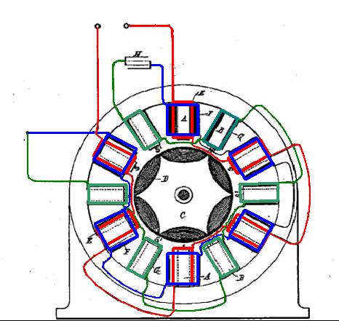

Thread Page 45

Re: Free Solid State/mechanical energy
« Reply #441 on: April 20, 2007, 08:04:51 PM »
Mmmm!!!! That team work sure smells good!!! Keep it going, pull tighter together, become a unit!!!
You guys are great!!

Thread Page 49

Re: Free Solid State/mechanical energy
« Reply #480 on: April 24, 2007, 10:37:56 PM »
Hello
I find myself laughing a lot lately.....I said that this is simple when you understand the fundamentals. This was not an exaggeration. The truth is here, some of you are beginning to see it.

The following is incorrect:
Quote
"Tesla Transformers are not magneto-electric devices, they use radiant shock waves, and produce pure voltage without current."

It should read:
"The "Electrical Transformer" is not an electromagnetic device, it is a Magneto-Dielectric device, it produces radiant shock waves, which is current transformed into pure voltage!"

Mainstream! It paralyzed your ability to think with power, to think imaginatively! You all refuse to see the simple truth that magnetism and electricity (static electricity) are one and the same. This is proven by the simple ignition coil! You all make me laugh! How is it that a magnetic field can be transformed into a field of high potential (electrostatic) in a transformer without itself being electrostatic? How does a magnetic flux line produce electricity? What is the nature of the flux line? In order for it to produce or induce electric effects it must also be electric! Chickens make chickens! The same law is in operation! LOL...this is great! Please doubt me, doubt everything that I am saying! Doubting only strengthens and supports all that I have said so far! Soon it will be realized that magnetic currents are electrostatic fields! Everything is electric! Soon it will be known by those who study that

Magneto-Dielectric Energy = Cold Electricity!

Quote
"568,176, is in a fact a cold current generation device. "

Which of you will be the first to use it! LOL!!!

Remember you can only build what you understand!!!

Regards

Thread Page 49

Re: Free Solid State/mechanical energy
« Reply #487 on: April 25, 2007, 10:28:47 AM »
Hello,
The reason why Tesla technology is not at the forefront right now, is because of the different opinions about his writings. He left us much information, as can be gleamed in his "Electrical Transformer", and "Coils for Electromagnets patents",

From patent 593,138 Electrical Transformer

“The length of the secondary coil B or of each secondary coil when two are used, as in Fig. 3, is, as before stated, approximately one-quarter of the wave length of the electrical disturbance in the secondary circuit, based on the velocity of propagation of the electrical disturbance through the coil itself and the circuit with which it is designed to be used – that is to say, if the rate at which a current traverses the circuit, including the coil, be one hundred and eighty-five thousand miles per second, then a frequency of nine hundred and twenty-five per second would maintain nine hundred and twenty-five stationary waves in a circuit one hundred and eighty-five thousand miles long, and each wave length would be two hundred miles in length. For such a frequency I should use a secondary fifty miles in length, so that at one terminal the potential would be zero and at the other maximum.”

“Coils of the character herein described have several important advantages. As the potential increases with the number of turns the difference of potential between adjacent turns is comparatively small, and hence a very high potential, impracticable with ordinary coils may be successfully maintained.”

“As the secondary is electrically connected with the primary the latter will be at substantially the same potential as the adjacent portions of the secondary, so that there will be no tendency for sparks to jump from one to the other and destroy the insulation. Moreover, as both primary and secondary are grounded and the line-terminal of the coil carried and protected to a point remote from the apparatus the danger of discharge through the body of a person handling or approaching the apparatus is minimum.”

From patent 512,340 Coils for Electro Magnets

“I have found that in every coil there exists a certain relation between its self-induction and capacity that permits a current of a given frequency and potential to pass through it with no other opposition than that of ohmic resistance, or in other words, as if it possessed no self-induction. This is due to the mutual relations existing between the special character of the current and the self-induction and the capacity of the coil, the latter quality being capable of neutralizing the self-induction for that frequency. It is well known that the higher the frequency or potential difference of the current the smaller the capacity required to counteract the self-induction; hence in any coil, however small the capacity, it may be sufficient for the purpose stated if the proper conditions in other respects be secured.”
he also left clues as to the nature of the force he was manipulating in some of the statements that he made!

"....If we could produce electric effects of the required quality, this whole planet and the conditions of existence on it could be transformed. The sun raises the water of the oceans and winds drive it to distant regions where it remains in state of most delicate balance. If it were in our power to upset it when and wherever desired, this mighty life-sustaining stream could be at will controlled. We could irrigate arid deserts, create lakes and rivers and provide motive power in unlimited amount. This would be the most efficient way of harnessing the sun to the uses of man......" (Nikola Tesla, June 1919)

This statement is one of Tesla's most important, as it specifically states electrical effects! This may mean nothing to many of you but it meant everything to Tesla, in this statement he reveals to all the nature of the sun, and it's main function! If magnetism as we understand it were the force, then he would have used the world magnetic instead of electric. In truth magnetism and electricity are one in the same, but not as we have been taught! Try and think of magnetism as being the painters canvas, and electricity being his paints and brushes! In this light magnetism becomes the rock, the immovable foundation upon which electricity builds! Looking at it this way simplifies everything as the only force we have to understand and comprehend is electricity!

"Ere many generations pass, our machinery will be driven by a power obtainable at any point in the universe. Through space there is energy. Is this energy (static) or kinetic? If static our hopes are in vain; if kinetic - and this we know it is for certain - then it is a mere question of time when men will succeed in attaching their machinery to the very wheel work of nature." Nikola Tesla

LOL.......Tesla was a beautiful mind! There are several ways we can approach his works. We can study his works and make the process of comprehension extremely complicated, or extremely easy. I prefer to look at this though the eyes of a child, as they teach us that we should be led by our imagination!

The sun is cold!

Don't get sidetracked we are still working on the first patent!
Regards

Thread Page 51

Re: Free Solid State/mechanical energy
« Reply #500 on: April 26, 2007, 07:33:35 AM »
Hello,
You all are really doing great research, but are still falling victim to mainstream! Think about it, if mainstream had the answer you would have it! Anything this big, and of this great an importance they cannot hide, nor would they want to! You are placing all of your faith and beliefs in what they have already spoon fed you. Those in high positions who know and use this technology (and have been for years even before Tesla!) love the fact that you choose to be ignorant of the facts! And the simple truth is that our science is not so much wrong as it is incomplete, powerful men with a plan established its foundation in quicksand!

It is up to each and everyone of you to come up with his/her own answer in the language of the layman! When you finally comprehend the fundamentals, regardless of what level you consider yourself to be at, we will be speaking the same language! Keep your questions simple and well thought out and the answer will be structured and organized.

The reason why I have not began discussions, is because you all are still not ready...there are still those who want to believe what they want to believe, and I respect this. I will not discuss this openly as I feel it will turn into a debate. That being said I will give you all even more time to discuss this amongst yourselves. You all know that our focus is the first patent, but I find that there is more discussion over other "seemingly" related things! This in itself is OK as long as the information being discussed is directly related to the functioning of the apparatus presented in the patent.

OK.....maybe this will help you focus. Please know this. What follows makes refrence to a spark gap (conversion element switching tube) Do not be lead off track, into the realm of spark gaps and what not, as there are none in the patents I have brought to your attention! The reason for posting this quote is not to inspire research into spark gaps, as they are not needed, The first patent and those which follow it prove this. I only want you all to see the secondary circuit (working circuit) in action! Show you one of the things it can do! Negative = Repulsive = Secondary!

****Side Note****
In classical circuits a resistance is often used to slow down or use up some of the current flowing through a line. The same holds true here the only difference is that a capacitor plays the role of the resistance, and at the same time a filter! It is not about charging nor discharging the capacitor as there is no break point in the circuit!
****
Taken from: "The Free Energy Secrets of Cold Electricity" By: Peter Lindemann, DSc

Quote
"Figure 31 shows another unpublished photograph taken by Tom Valentine in Ed Gray's laboratory in 1973, showing Ed Gray and Fritz Lens at their laboratory bench. The arrangement of parts shown in the foreground is the setup used to demonstrate the "popping magnets." In the lower left portion of the photograph is what appears to be an air core transformer wound on a 4-inch diameter piece of PVC, resting on some wooden blocks (Figure 32). This circuit element is probably taking the discharge from the conversion element switching tube and inductively coupling it to a secondary winding.

"It is the secondary winding that powers the magnets, which are wired in series, making them fly away from each other. In order to create repulsive impulses that are timed perfectly to each other, Gray has this air core transformer powering the magnets simultaneously. He is using an air core transformer here in the first stage, because the impulse frequency is so high. A digitally-enhanced close-up image of this component shows the central winding as two layers of ten turns each of what looks like spark plug wire." pgs. 55-56End Quote

Please try and stay focused. It is OK to bring in info from other sources, but it must be directly related to the subject.

When you realize that we are using the currents manifested in the secondary windings only, this will mark the moment that you begun to change your thinking, and have received your first true taste of the force Tesla was working with.
Regards

Thread Page 54

Re: Free Solid State/mechanical energy
« Reply #530 on: April 27, 2007, 10:40:17 AM »
Hello,
Hmmmm!!! Maximumgravity asked a smart simple, and straight to the point question, he even provided us with the answered to the first part of the question himself:

Quote from: Maximumgravity1 on April 27, 2007, 02:30:05 AM
My simple organized question:

How does a condenser act as a filter, and what is it filtering?

I see some idea of an answer in brnbrade's answer, but the language barrier is a bit tough to overcome - but I appreciate the thoughts and attempts none-the-less. It seems if there is a resonance developed in the secondaries, this might be along the right paths.

Mainstream would tell us that a condenser is a series of plates (2 in its simplest) separated by a dielectric (insulator). The charge on one plate is opposite that of the other plate. The potential difference between the two causes the capacitance (ability to store energy) to store in the electrostatic field formed between the two plates. We are also told it produces impedance to alternating current.

and allcanadian finished it off by providing the answer to the last part of the question. Now that's what I call team work!

Quote from: allcanadian on April 27, 2007, 06:41:51 AM
But there is an additional feature of interest about this motor, namely, it is not necessary to have even a single connection between the motor and generator, except, perhaps, through the ground; for not only is an insulated plate capable of giving off energy into space, but it likewise capable of deriving it from an alternating electrostatic field, though in the latter case the available energy is much smaller. In this instance one of the motor terminals is connected to the insulated plate or body located within the alternating electrostatic field, and the other terminal preferably to the ground.
Regards

Thread Page 56

Re: Free Solid State/mechanical energy
« Reply #554 on: April 28, 2007, 04:35:59 PM »
LOL Huh
Mainstream Lips Sealed
Gotta love it........ Undecided
Regards

Thread Page 56

Re: Free Solid State/mechanical energy
« Reply #559 on: April 28, 2007, 11:38:48 PM »
Hello,
Quote from: Charlie_V on April 28, 2007, 06:45:31 PM
Erfinder, explain what you think is mainstream?

Just try thinking for yourself! I believe I have said on more than one occasion that it is advisable to put everything you think you know on the sidelines, as it will not help you at present, it will only hinder your comprehending the new information. Later when you comprehend, and have transformed this new information into knowledge, you can refer back to that which mainstream has given you!

Mainstream is nothing more that the source of information we collectively call knowledge. What we call knowledge is not knowledge it is information! Knowledge reveals cause, describes cause, explains cause! At present we don't know the cause of ANYTHING! We are masters of effect only!!!

Quote from: Charlie_V on April 28, 2007, 06:45:31 PM
I have some questions for you actually.

1.) Is each individual coil (the secondary 144 inch coils) suppose to be 1/4 wavelength or is all 4 together suppose to make a 1/4 wavelength?

I thought that it was clear that our focus is the first patent? What does this have to do with the patent?

Quote from: Charlie_V on April 28, 2007, 06:45:31 PM
2.) I've seen you say that each coil makes a plate of a capacitor. Do you mean that each transformer (primary wrapped around a secondary) will produce a voltage during their coupling that will add like charged capacitors do in series?

Interesting!?!?

You must look at this apparatus as a whole instead of concentrating on it's parts alone! The entire machine is a transformer! You and all others viewing are very much aware what happens when a magnetic field collapses! You all know how currents of low potential are transformed into currents of high potential! You all know what is happening here! Why you are making this into something that it is not is beyond me! I want to discuss what is happening not teach it! If you cannot see what is happening for yourselves then.......You have been taught that the secondary currents are good for nothing other than sparks...this is the biggest lie you have ever been sold! I will not waste our time trying to explain to you why, others have done a good job of this already, you just have to know where to look, and most importantly know what to look for! I realize that I still haven't answered your question! So try this on for size. The secondary windings are extensions of the capacitor plates!!! lol....

Quote from: Charlie_V on April 28, 2007, 06:45:31 PM
3.) You seem to ignore magnetic fields, why?
`
You assume that magnetic fields exist! One day science will discover the nature of that which they call a magnetic line of flux! When they do, it will be observed that it is an electrostatic field of extreme density, centered by the Still Magnetic Light. Magnetism is Still Light. We cannot use it! It is the fulcrum, the foundation! Foundations don't move. Electricity on the other hand moves in two directions simultaneously! These two opposite directions are opposite to one another meaning they travel 180 degrees from the neutral point dividing them! One direction is the direction of compression, and the other is the direction of expansion. What must be visualized is that these two can move in the same forward direction and still be moving in opposite directions! How? Dual Vortex!!! One small vortex moving in one direction through a larger moving in the opposite direction, the larger is expelled from the smaller!!! As I believe I have said before it (magnetism or the Still Magnetic Light) should be viewed as the artists canvas, and the imagined idea that the artist wants to convey, while electricity serves as the brushes, paints, and potential of the artist to express (simulate) his/her idea!
Regards

Thread Page 57

Re: Free Solid State/mechanical energy
« Reply #567 on: April 29, 2007, 07:18:51 AM »
Hello,
Vacuum, what it really is and how it is produced like Schappeller did it will be discussed in the next patent! But before we can get there you have to try and focus on the simplicity of the patent we are presently working on! Your collective explanations are extremely complicated. If you all think this is complicated, you are in for a surprise if and when we ever make it to the next patent!

I told you all there is more to this then any of you have ever imagined, but before we can take a walk on the wild side and begin to experience truth, you must change your thinking!
Regards

Thread Page 58

Re: Free Solid State/mechanical energy
« Reply #572 on: April 29, 2007, 10:10:59 PM »
Trump,
Quote from: Trump on April 29, 2007, 05:59:42 PM
Ok, so we need to change our thinking, It seems that everyone has talked this patent to death.

I am in agreement with you, you all have talked this patent to death, but where is the fruit of your discussions? Your discussions have not brought any of the hidden truths of this patent to light, this means your thinking has not changed! It has remained the same from the beginning until now!

Quote from: Trump on April 29, 2007, 05:59:42 PM
What else can we do to change our thinking of how to evaluate the Patent?

For starters look at the patent again, and this time take note of the secondary windings. At the same time look at the capacitor! What do they have in common? Hmmm, (simple obvious observation) could it be that they both interact with electrostatic fields! (starting role playing...teacher student) Interesting.... Question: How do they interact with electrostatic fields? Answer: Well the capacitor stores electrostatic charge as a stress potential in it's dielectric material, and the secondary windings radiate electrostatic charge! Hmmmm.....interesting....is there anything else? Yes! The capacitor and the secondary windings are to be seen as one unit, one system! The coupling of the secondary windings with capacitor produces a special capacitor! It should be understood that when the magnetic field of the primary collapses, a unidirectional (direct current in the form of a penetrating radiation) radiation is emitted from the conductor, this radiation is absorbed by the secondary and manifests as a high potential electrostatic field. What should be noted is that the polarity of the the secondary windings alternate! This is important as it shows us how a unidirectional (direct current) electrostatic field potential is transformed into an alternating one!!!

Quote from: Trump on April 29, 2007, 05:59:42 PM
Is it the idea that we need to realize why things happen in this patent and not how they happen?

Trump

Of course this is what you should be doing! Unfortunately the bulk of your efforts are on gathering enough information to possibly construct a similar device! Roll Eyes The whys, and how's of machines functions are not as interesting as a working device for some of you!

Is anyone listening? Tesla was a true genius, read and reread his patents!
Regards

Thread Page 62

Re: Free Solid State/mechanical energy
« Reply #619 on: May 2, 2007 at 03:25:41 PM »
Reply with quoteQuote
Huh

It has become painfully clear that I cannot help if we are not on the same page, so here is were you all need to start. Those of you who are ready to move forward will know how to contact me.

Start viewing and reading!!!

Secrets of Cold War Technology ISBN: 0-932813-80-1
The Free Energy Secrets of Cold Electricity
(Video) The Free Energy Secrets of Cold Electricity

and of course the patents:

464,666 Electro Magnetic Motor (1891)
512,340 Coils For Electro Magnets (1894)
568,176 Apparatus For Producing Electric Currents of High Frequency and Potential
568,177 Apparatus For Producing Ozone
568,178 Method of Regulating Apparatus For Producing Currents of High Frequency
593,138 Electrical Transformer

Walter Russell

A Course In Cosmic Consciousness; Transformational Study Of Universal Law, Natural Science, And Living Philosophy
The Universal One
A New Concept of the Universe
The Book Of Early Whisperings
The Secret Of Light
Atomic Suicide
The Russell Genro-Radiative Concept
The Message Of The Divine Illiad Vol. I
The Message Of The Divine Illiad Vol. II

Viktor Schauberger

Hidden Nature ISBN: 0-86315-432-8
Living Water ISBN: 0-7171-3390-7
The Vortex Key To Future Science ISBN: 1-85860-019-7
Living Energies ISBN: 0-7171-3307-9
The Water Wizard ISBN: 1-85860-048-0
Nature As Teacher ISBN: 1-85860-056-1
The Fertile Earth ISBN: 1-85860-060-X
The Energy Evolution ISBN: 1-85860-061-8
Unser Sinnlose Arbeit ISBN: 3902262001
Das Wessen des Wassers ISBN: 3-03800-272-0

Karl Schapeller

The Physics Of The Primary State Of Matter

Nikola Tesla

Colorado Springs Notes 1899-1900
Nikola Tesla Collected German And American Patents
Nikola Tesla Collected Articles And Lectures Vol. 1
Nikola Tesla Collected Articles And Lectures Vol. 2

T. Henry Moray

The Sea Of Energy In Which The Earth Floats

Keely

Universal Laws Never Before Revealed: Keely's Secrets
The Physics Of Love
Keely And His Discoveries

Leedskalnin

A Book In Every Home
Magnetic Current
Magnetic Base
Cosmic Force
Regards

